Material parameters

Symbolic name Real name Symbol
MLD_COHESION "Cohesion" C
MLD_FRICTIONANGLE "Friction Angle" ϕ
MLD_POISSONRATIO "Poisson's Ratio" ν
MLD_YOUNGMODULUS "Young's Modulus" E
MLD_BULKSTIFFNESS "Bulk Stiffness" K
MLD_SHEARMODULUS "Shear Modulus" S
MLD_DYNUNISTIFFNESS "Dynamic Uniaxial Stiffness" E_{d}
MLD_DYNSHEARSTIFFNESS "Dynamic Shear Stiffness" G_{d}
MLD_RHOB "Rho b" ρ_{b}
MLD_VELOCITYP "Vp" v_{p}
MLD_VELOCITYS "Vs" v_{s}
MLD_POROSITY "Porosity" n
MLD_INITFRICTION "Initial Friction Angle" ϕ
MLD_HARDENING "Hardening Parameter" λ
MLD_PRECONSOLIDATION "Preconsolidation Stress" P_{c}
MLD_CAPSHAPE "Cap Shape Factor" α
MLD_DILATATION "Dilatation Angle" ψ
MLD_LATRATIO_MAX "SHtot/Svtot"
MLD_LATRATIO_MIN "Shtot/Svtot"
MLD_AZIMUTH "SHtot azimuth"
MLD_INIPORO "Porosity" n₀
MLD_LATRATIO "Lateral Total Stress Ratio"
MLD_INISTRAINRATE "Initial Strain Rate" 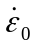
MLD_VPPROCPARAM "Viscoplastic Process Parameter" κ
MLD_A1 "A1" A₁
MLD_n1 "n1" n₁
MLD_A2 "A2" A₂
MLD_n2 "n2" n₂

Material models

Symbolic name Real name
MLD_LINEAR "Linear"
MLD_CAMCLAY "Cam-clay"
MLD_MOHRCO "Mohr-Coulomb"
MLD_MODMOHRCO "Modified Mohr-Coulomb"
MLD_CREEP "Fokker Creep"
Gebruik in material models

MLD_COHESION ALL
MLD_FRICTIONANGLE MLD_LINEAR, MLD_MOHRCO, MLD_MODMOHRCO, MLD_CREEP
MLD_POISSONRATIO ALL
MLD_YOUNGMODULUS ALL
MLD_BULKSTIFFNESS MLD_LINEAR
MLD_SHEARMODULUS MLD_LINEAR
MLD_DYNUNISTIFFNESS MLD_LINEAR
MLD_DYNSHEARSTIFFNESS MLD_LINEAR
MLD_RHOB MLD_LINEAR
MLD_VELOCITYP MLD_LINEAR
MLD_VELOCITYS MLD_LINEAR
MLD_POROSITY MLD_CAMCLAY
MLD_INITFRICTION MLD_CAMCLAY
MLD_HARDENING MLD_CAMCLAY, MLD_MODMOHRCO
MLD_PRECONSOLIDATION MLD_CAMCLAY, MLD_MODMOHRCO
MLD_CAPSHAPE MLD_CAMCLAY
MLD_DILATATION MLD_MOHRCO
MLD_LATRATIO_MAX ALL
MLD_LATRATIO_MIN ALL
MLD_AZIMUTH ALL
MLD_INIPORO NONE
MLD_LATRATIO NONE
MLD_INISTRAINRATE MLD_CAMCLAY
MLD_VPPROCPARAM MLD_CAMCLAY
MLD_A1 MLD_CREEP
MLD_n1 MLD_CREEP
MLD_A2 MLD_CREEP
MLD_n2 MLD_CREEP

Omrekeningsformules Linear material

E, ν -> K, S
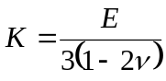
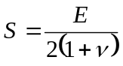

E, ν -> E_{d}, G_{d}
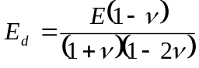
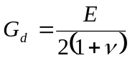

E_{d}, G_{d} -> ρ_{b}, v_{p}, v_{s} (ρ_{b} vast)
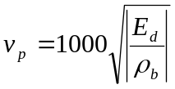
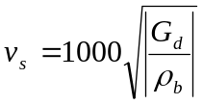

K, S -> E, ν
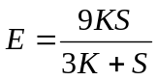
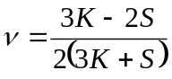

K, S -> E_{d}, G_{d}
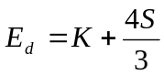
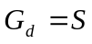

E_{d}, G_{d} -> E, ν
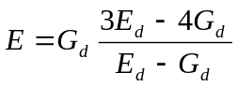
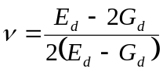

E_{d}, G_{d} -> K, S
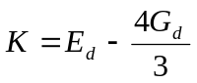
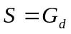

ρ_{b}, v_{p}, v_{s} -> E_{d}, G_{d}
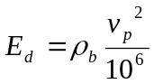
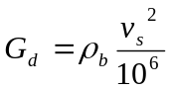

Header definities Shell

Shell header Symbolic name
YoungsModulus MLD_YOUNGMODULUS
PoissonsRatio MLD_POISSONRATIO
Cohesion MLD_COHESION
FrictionAngle MLD_FRICTIONANGLE
Porosity MLD_POROSITY
BulkDensity MLD_RHOB
CompressionalVelocity MLD_VELOCITYP
ShearVelocity MLD_VELOCITYS
VerticalPermeability (not used)
HorizontalPermeability (not used)

